**Assignment 2**

1. Whose name start with any one alphabet.

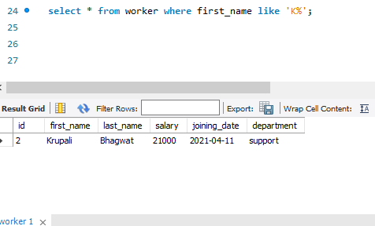

1. Use between operator to fetch the salary of worker

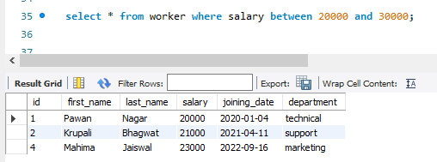

1. Use AND operator & the wildcard operator to fetch the data of worker based on there departments and name

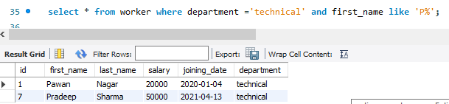

1. Fetch the data by their salary in descending order.

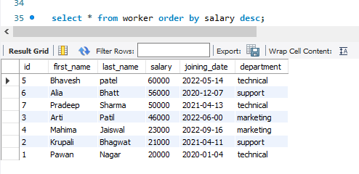

1. Calculate the maximum salary from each department where salary should be greater than 50000.

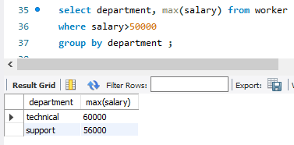

1. Write SQL query to fetch details of the workers who are also the managers.

